

**Innovative & Immersive**

**Fitness Experience**

**UX Design Document**

**Created For**

**Sense | Think | Act**

**Company’s Contact:** Farjana Salahudin | Khalid Al Ali

**Team Members:** Ahmed Issaoui | Jewel Dsouza | Mariam Al Thani | Raghad Abunabaa

**Advising Professor:** Selma Limam Mansar

**Course:** Information System Consulting Project | Spring 2023

**Date:** Thursday 13th April 2023



# 

# User Experience Design Documentation

# Introduction

The User Experience (UX) designer document presents an in-depth reference to the UX design and development process for our immersive fitness experience. This document aims to provide a glimpse into how we have designed and structured the UX to be simple, effective, and entertaining for our users. The audience to be served for this document comprises the developers, stakeholders, and any individual engaged in the conceptualization and creation of the experience, mainly in STA. Through this document, we intend to foster a common understanding of the UX and improve collaboration among members of the team. The following guide includes user research, personas, storyboards, flow of the user experience, visual design of the character, environment and fonts used, and finally the results of user testing.

# Research

## Objectives

As part of our effort to develop a user-focused design, we conducted an extensive research to acquire insights concerning our audience, as well as the in-depth nature of the experience. The study sought to comprehend users’ characteristics associated with the intended application of the experience, determine user requirements, goals and expectations, and learn about their preferences regarding the attributes and functions of the experience, as well as assess the ease of use while identifying any areas for enhancement.

## Methods

We employed the following research approaches to attain our objectives:

* Market analysis: we carried out market research to uncover potential opportunities by identifying conceivable gaps in the market that could potentially be addressed with an innovative immersive experience. In addition, we investigated and examined previous immersive experiences in order to identify emerging techniques to distinguish ourselves and exceed users’ expectations. Furthermore, we studied market trends in the market by analyzing users’ practices, and upcoming technologies in the market.
* Product analysis: we performed product analysis to identify the experience’s abilities, shortcomings, prospects, and challenges. We researched current immersive experiences in order to learn about fundamental features and abilities such as what it essentially accomplishes, its method of operation, and what positive effects it delivers to users. In addition, we looked at various designs including its physical characteristics, structure and functionality. Furthermore, we evaluated the experience’s quality considering its enduring nature and consistency, as well as its efficacy in conveying the message.
* Usability testing: we conducted usability tests to assess the user experience to ascertain that the experience is easy to navigate, successful and effective, along with identifying potential areas for improvement.

## Results

Our research findings influenced our choices regarding design and assisted us in selecting the characteristics and functions that are going to provide the greatest impact to prospective users. Among the important results are:

* Qatar is notable for and has publicly acknowledged the widespread prevalence of unhealthy lifestyles, obesity, and diabetes among its whole population (Al-Thani et al., 2018; Chrismas et al., 2019; Cheema et al., 2022). Moreover, the country adopted a number of measures to address the problem (Aspetar Orthopaedic and Sports Medicine Hospital., 2021; Weill Cornell Medicine, 2022). These preliminary findings suggest fitness as a key message to convey.
* Immersive experiences have been successfully introduced in Qatar. The themes ascribed from already existing experiences spanned from culture to environment to global communication. However, according to our study, there has been no immersive fitness experience developed before in Qatar, making it a one-of-a-kind experience.
* Immersive fitness experiences established outside Qatar primarily involve a simulated setting that imitates a fictional environment in which the user perceives that they are present in the setting. In addition, the experience included an immersive exercise in which the users feel that the game is tailored to their needs as they have control over the actions of the character displayed in the environment. Finally, the experience also included real-time information on how the user performs throughout the game, measured in different metrics. These findings are the fundamental features identified in each immersive fitness experience and have been used to guide the development process.
* Concepts for immersive fitness environments aren’t merely restricted to gaming scenarios or limitless expanses, but may also include real-world settings such as cities or towns. Game setting and infinite spaces, on the other hand, have been commonly augmented to give an entertaining yet challenging immersive experience. This is mostly because game settings, similar to video games, are capable of providing users with an enjoyable and participatory experience that includes goals and incentivizes users to exercise more. Meanwhile, endless settings allowed individuals to travel in any fashion they envisioned, with obstacles surfacing arbitrarily in order to preserve the interest of users. By combining video game settings with abstract realistic environments and our technical abilities, we aim to create a unique selling point for users by making them feel that they are in a different world.
* Numerous contemporary immersive experiences entail showcasing users’ motions or enabling them to make their way around inside the virtual world without any observable avatar or figure. Although this strategy might provide an illusion of autonomy and immersion, it likewise may leave the user experiencing a little emptiness or without emotional interest. Consequently, we have elected to include a character in the experience to provide depth and engagement. By allowing users to possess or engage with their digital figure, they can cultivate a deeper psychological attachment to the experience, as well as a higher feeling of control inside the virtual environment. However, it is critical to ensure the simplicity of the character to make it applicable to a wide range of audience and not too specific to not exclude other users.
* Recent immersive fitness experiences frequently call for two or more individuals to participate in the experience at a given time to boost their enthusiasm and involvement. However, owing to time limits, it was not viable to include multiple people in the workout. However, we created a new technique to preserve the competitiveness of the experience by introducing a leaderboard which highlights users’ scores at the end of each session. This concept empowers users to compete against themselves, as well as others who have gone through the experience with better scores, establishing an atmosphere of competitiveness and urging them to utilize the experience repeatedly. By attempting to outperform their or others’ prior scores, users are more inclined to participate in the experience consistently and motivate themselves to do better.
* Participants noted areas for improvement, which mostly include providing tutorials and hints to assist the user on the anticipated movements, as well as enhancements to the character to give the user the feeling that they are part of the game and have the ability to control the game.

## Implications

Immersive fitness experiences possess an opportunity to promote dedication to ongoing exercise regimens by making exercise more intriguing and exciting, which in turn positively impacts physical health. By offering an interactive and engaging atmosphere that simulates and challenges individuals, it can boost individual’s motivation, as well as their participation in exercises. Therefore, In order to establish an ambiance that excites the senses and grabs the interest of users, the design should include components such as modern technology, dynamic lighting, and sound systems. In addition, exercise has been demonstrated to improve mental health, and the proposed experience can augment these benefits by offering a feeling of belonging, socialization and supportive reinforcement. Therefore, the experience will have to incorporate elements that would allow them to interact with other users. Moreover, the potential of the immersive fitness experience to appeal to a wide range of audience could result in the rise of new business opportunities that have the opportunity to cause havoc in the conventional fitness sector through introducing novel and creative methods to exercise. Thus, the design should address the various needs and interests of potential customers to attract a wide audience. This might involve developing distinct themes or experiences for various ages, or levels of physical activity.

# User Personas

Our immersive fitness experience seeks to deliver an innovative and enjoyable exercise session for everyone, irrespective of fitness level or expertise. While our platform may be utilized by a broad spectrum of audiences, we have only a single user group which provides consistent and effective functionality. The reason for this is because our platform is built on a certain set of functions that have been meticulously created to improve the user's exercise experience. These features are intended to be useful for all users, regardless of their own fitness expertise.

Although certain users may have unique objectives or habits, our experience strives to give a complete training experience that meets a wide range of fitness requirements. As opposed to categorizing our user base according to distinct goals or interests, we believe sustaining a single user group enables us to focus on providing the greatest possible exercise experience to all consumers.

Overall, we believe that our immersive fitness experience will present individuals with a difficult and entertaining exercise experience, regardless of their specific objectives or interests. Our experience is intended for a diverse variety of users, and we are dedicated to providing a consistent and successful training experience for everyone who utilizes it.

# Storyboards

We designed a storyboard to depict an ordinary user experience in order to more effectively convey and communicate the experience, and to emphasize the essential components of the immersive fitness experience. The following information represents the storyboard.

## Start Screen

The immersive experience aims to provide users with a lively and participatory environment that stimulates them on various fronts. The digital environment has been configured to continue moving indefinitely, delivering a feeling of perpetual motion and velocity to the immersion of the experience. A message is also displayed on the screen, asking users to connect their hands, establishing an in-person connection between users and commencing the immersive experience. In addition, there will also be stickers on the floor to indicate to the user where they should be when they move to the left, right or center. This configuration delivers an experience that pushes users to come together and get active.

## Tutorial

After joining hands, there will be a tutorial page to demonstrate how to carry out the moves to avoid the obstacles is a vital element of the configuration. The tutorial will aid users in avoiding accidents through making certain that they learn how to execute the activities properly and securely. It also guarantees that users make the greatest possible use of the experience by performing the actions correctly. Finally, the tutorial could also improve the whole experience by offering an explicit knowledge of the workout’s objectives, allowing users to solely concentrate on attaining their fitness goals.

## Game Start

The user is taken to a simulated environment that mimics the endless expanse seen on the start screen. The setting also comprises a figure that the user controls, as well as obstacles that pop up unpredictable as the game progresses. The user controls the character’s motions, which must be accomplished in order to circumvent the obstacles and progress through the game. The setting also features the lives available to the user on the left side, whereas the scores are included on the right side of the screen. In addition, written instructions will be displayed on the screen, indicating what actions the player should perform next to escape the obstacles and finish the game. If the user hits an obstacle, they will lose a life. Otherwise, they will gain extra points for avoiding the obstacles.

## Game End

The experience will ultimately end when the user runs into three hurdles and has lost all of the three lives. At that moment, the setting switches to show a leaderboard with the game’s highest ten rankings. This allows the user to assess their progress to that of others, as well as potentially seek the greatest score. In the meantime, a countdown timer is also displayed with the leaderboard, allowing users to view the final results and choose whether to keep playing by rejoining hands before the timer ends. Otherwise, the game will navigate back to the instructions where other users can begin the game by joining hands.

# UX Designer Style Guide

The UX design style guide’s main objective is to give a thorough list of guidelines in order to maintain uniformity and cohesiveness throughout all design aspects of the experience. The style guide is the foundation for the aesthetic and user-friendly layout of the experience, presenting critical elements to the design process of the environment, obstacles, as well as the character, which are discussed below.

## Environment Design

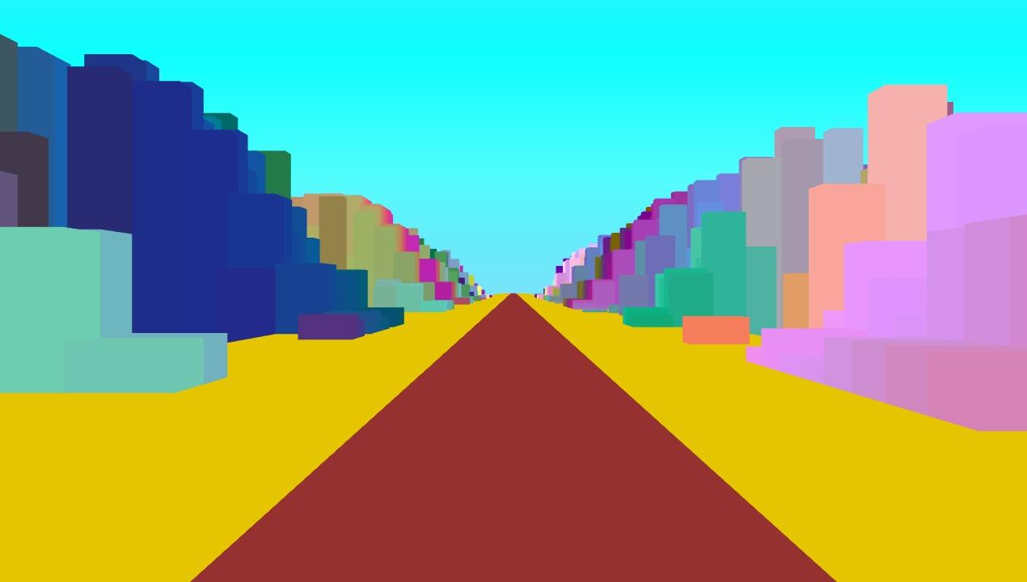The ongoing development of the virtual setting was a vital component of the development phase. Early on, the setting was intended to be less abstract, imitating a real-life setting such as Qatar’s Old Port or West Bay.

**Figure 1:** *First iteration of environment Design*

As the concept evolved, the team concluded that a more abstract setting would make users have a sense of attachment to the other world as discussed in the findings of the research conducted. The environment design evolved into the following:

**Figure 2:** *Second iteration of environment design to be more abstract.*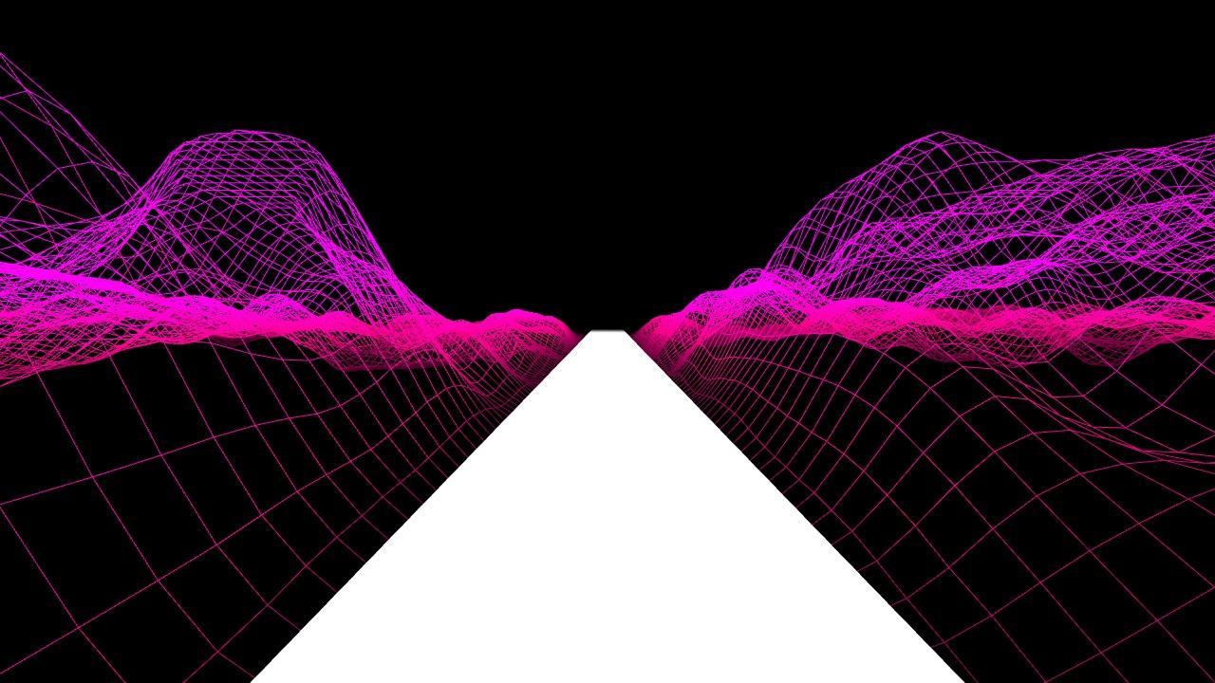

The team investigated the different methods to build an abstract world. However, it became evident during client sessions and user feedback that the technique did not give the intriguing look and texture as anticipated by the client and users. The atmosphere was drab and unappealing to users, thus degrading the experience.

In response to the feedback received from the client and users, the team adopted a more abstract and conceptual technique for landscape layout, emphasizing on delivering an exceptional and deep experience. The team utilized conceptual elements including patterns of geometric designs, vibrant shades, and illuminating effects to establish an exotic and vivid scene. The team succeeded in managing to create an environment that made users get more attached to the other side, the experience, through the development of more abstract settings that improved the experience as a whole. In addition, the abstract setting allowed users to relax and leave their daily challenges and fully immerse themselves in the experience, making it more interesting and effective. Thus, we have finally developed successful environments that were seen as attractive by both the client and users as shown below.

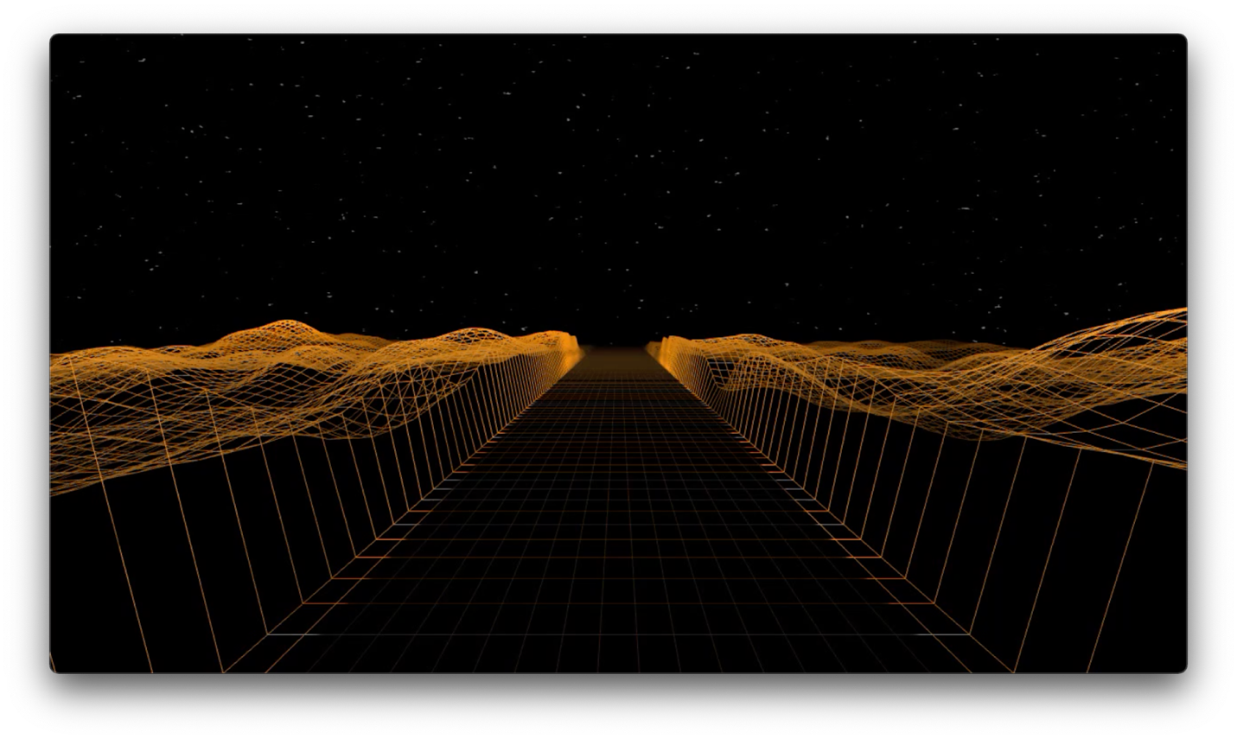

* 1. Desert Dunes during the night

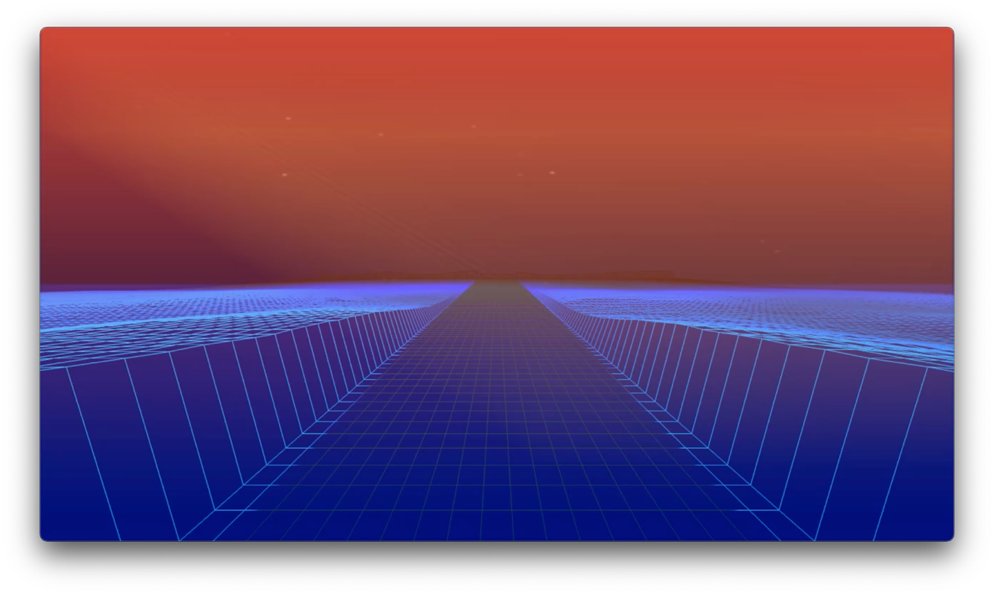

* 1. Ocean Landscape during sunset

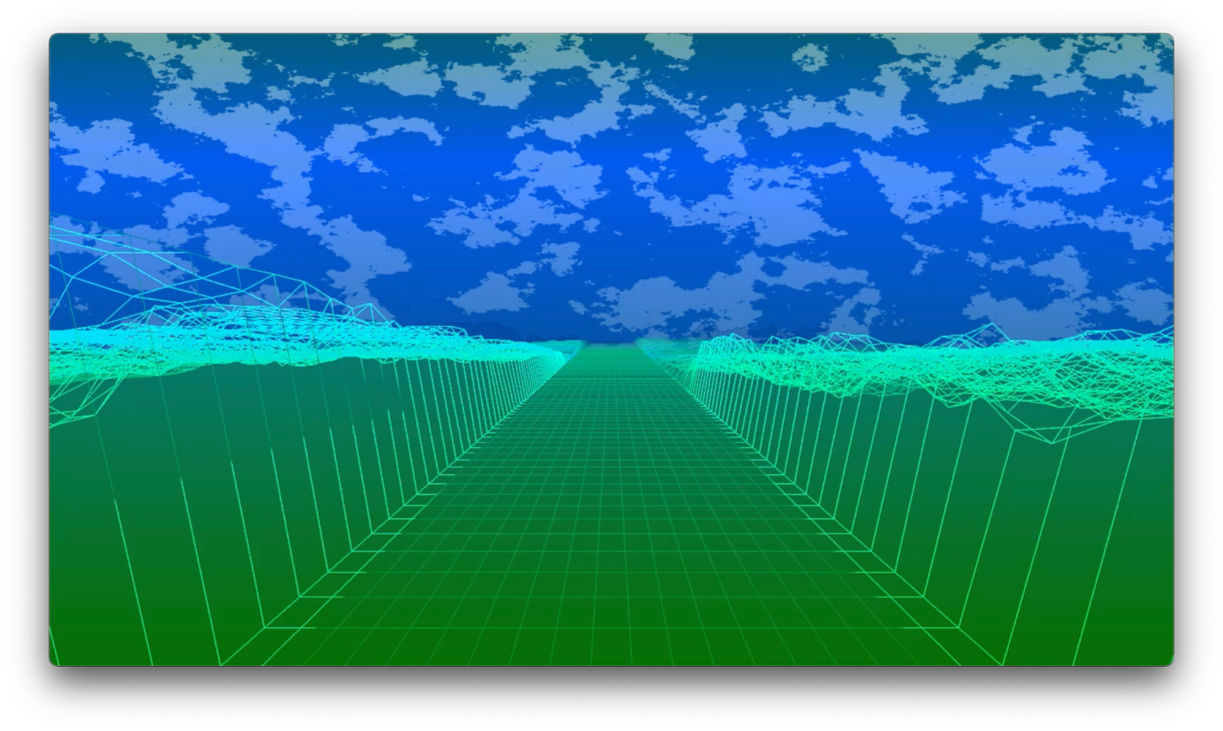

* 1. Mountain Landscape during the day

These three environments act as the selling point for the experience as they allow the user to experience different regions with increasing difficulty level.

## Character Design

The character’s evolution can potentially be noticed as a succession of modifications influenced by feedback from both users and STA. For cleanliness and ease of use, the shape of the persona was first depicted as a rectangle. However, as the design evolved and the user experience was polished, a running avatar was constructed using sprite graphics as discussed in the initial requirements which was then embedded into the experience. Following feedback from STA, the team concluded that the initial avatar layout was too precise, possibly leaving our certain demographics. As a result, we streamlined the design by developing a stick figure designed to appeal to a broader audience. Further feedback suggested that users prefer a figure that mirrors their actions as it makes the experience more interactive and captivating. The following pictures show the evolution of our character:



1) 2)



3) 4)

## Obstacle Design

The obstacle design is expected to be adapted to the unique needs of the experience, presenting obstacles suited for participants’ level of endurance and objectives. The team intends to make the obstacle design more three-dimensional and blended with the surrounding environment in order to improve the immersive experience. This is mainly through employing various gradients and forms that are more representative of the environment, which is expected to make the experience more enjoyable for users. We have used different obstacles for the different movements that suit the different environments' context as shown below.

